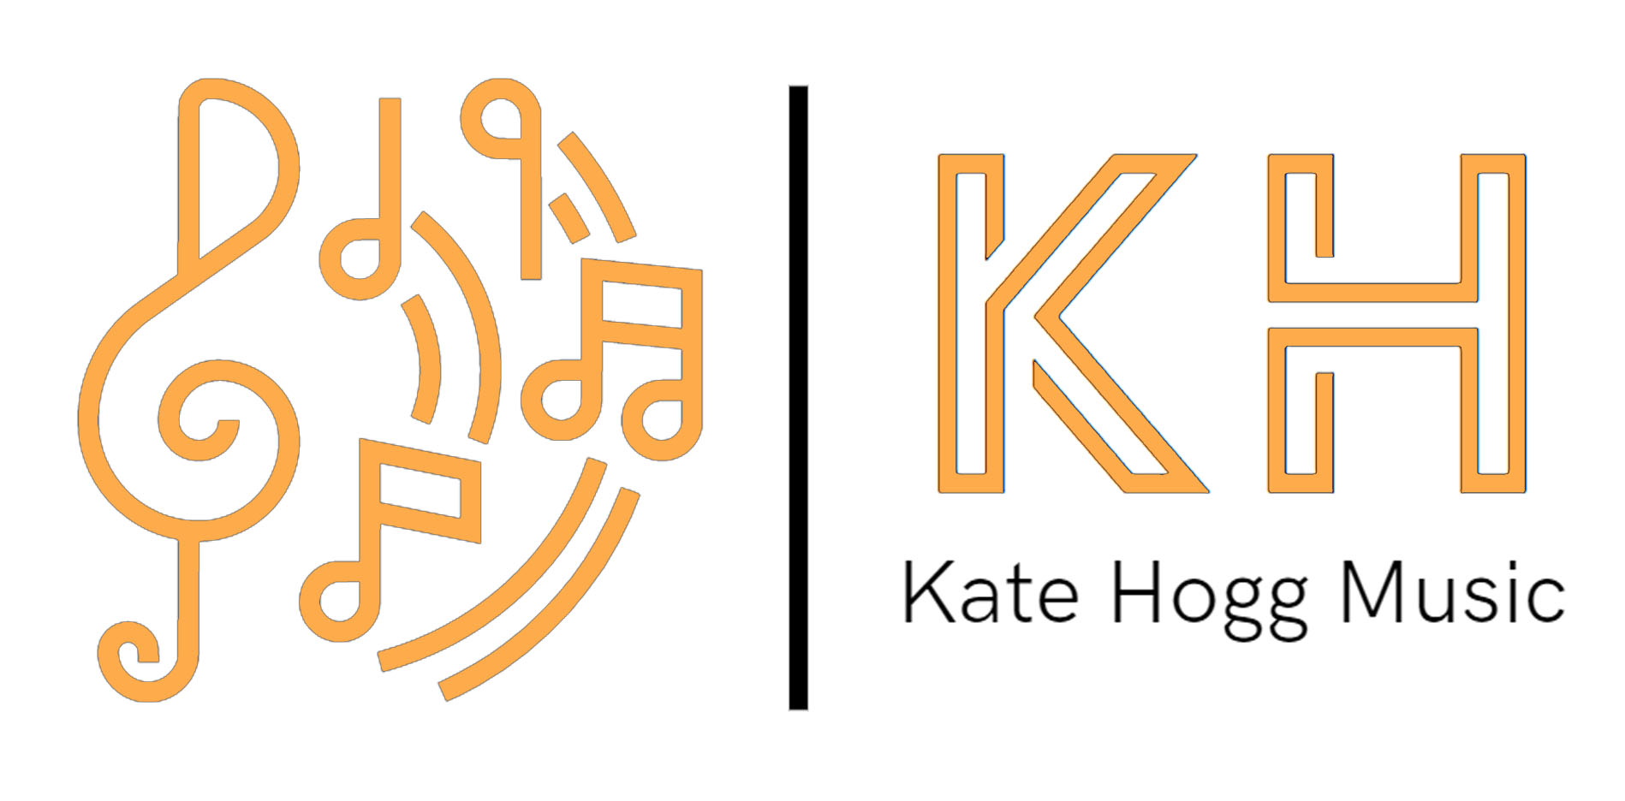

GDPR POLICY
Notice May 2021
Personal Data
Kate Hogg is the ‘Controller” of the personal data that you provide.

What I need
Unless otherwise agreed with you, I will only collect basic personal data about my clients, students and associates. This information may include your name, home address, e-mail address, date of birth, bank details, education details, qualifications, employment history, any medical conditions or special educational needs data and ongoing academic records.
I may also need to record, film/ or photograph clients, students and associates. I also hold information about students’ musical education including lesson plans, observations, progress, objectives, exam results and reports.

Why I need it
I process personal information to enable me to provide tuition to students, to maintain my own accounts and records and to support and manage my associates. I will not collect any personal data from you that I do not need.

What I do with it.
All personal data that I hold about you will be processed by Kate Hogg in the UK. Some information may also be shared with the following third party organisations as needed:

My Music Staff
Accountant
Bank
Examinations Boards and Music Festivals

No other third parties will have access to your personal data unless there is an obligation for me to provide it. I will take all reasonable steps to ensure that your personal data is processed securely.
I will generally keep your personal data for a minimum of 6 years, after which time it will be destroyed if it is no longer required for the lawful purpose(s) for which it was obtained.

Your rights and responsibilities.
You have the right to request that your data is amended or deleted at any time. You also have the responsibility for ensuring the data I hold is accurate and current. In both cases, any queries should be directed to katehoggmusic@gmail.com. More information about your rights can be found on the Information Commissioner’s website at www.ico.org.uk.

Changes to this policy
This privacy notice will be periodically reviewed and updates where necessary. Current students will be informed accordingly and the latest version will be available at https://katehoggmusic@mymusicstaff.com

