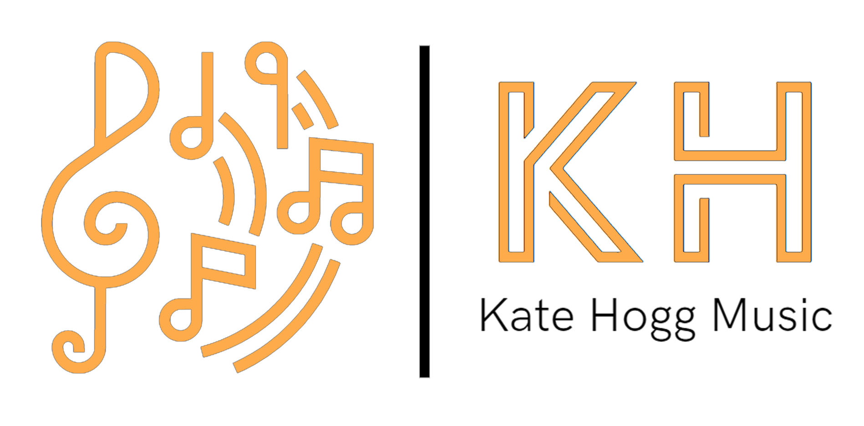
Email: katehoggmusic@gmail.com
Terms and Conditions of Instrumental lessons
Lessons
- Lessons will be given during the school term, totalling 33 in the academic year.
Payment of fees
- The parent/carer will pay the invoice each term before the first lesson of each term. You can set up a standing order with you bank to pay monthly or half termly also.
- Please make payment via BACS payment direct to:
Katherine Hogg Starling Bank
Sort code: 60-83-71 Account Number: 17912803

Missed Lessons
- Where lessons have been missed because the pupil has been absent or unavailable, a refund or credit will not be given except for special reasons such as prolonged illness. Refunds will not be given because the pupil has been absent / unavailable due to occasional illness, school trips, examinations, study leave, forgetfulness, or similar reasons.
- I will refund payment for lessons that I miss or will credit the amount to the next half term’s lessons.
Online tuition/Covid
- In the event that face- to- face tuition is interrupted/halted as a consequence of Covid-19 I will offer online tuition.
Termination of lessons
- Half a term’s notice is required to stop lessons.
Fees
- Individual 30-minute lesson - £22.20
- Individual 20-minute lesson - £14.80
- Shared 30-minute lesson - £10.95

