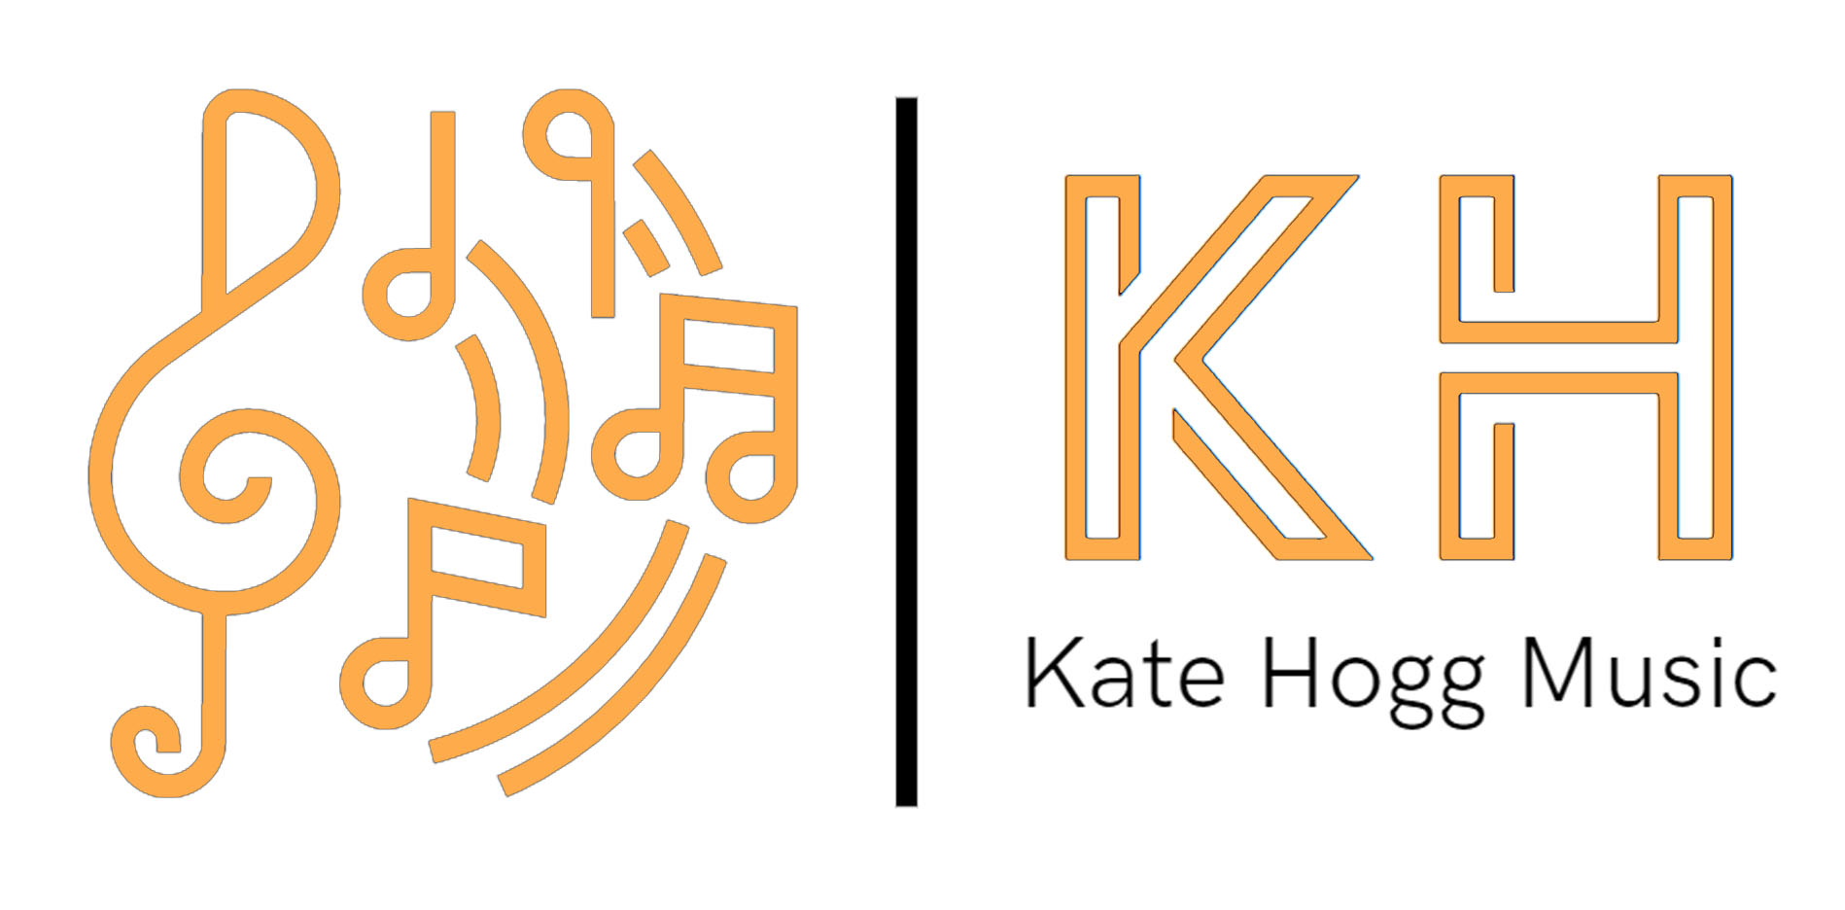
Safeguarding Policy
I believe that:

- Children and young people should never experience abuse of any kind
- I have a responsibility to promote the welfare of all children and young people, to keep them safe and to practise in a way that protects them.

I recognise that:

- The welfare of children is paramount in all the work I do and in all the decisions I take. All children, regardless of age, disability, gender reassignment, race, religion or belief, sex, or sexual orientation have an equal right to protection from all types of harm or abuse.
- Some children are additionally vulnerable because of the impact of previous experiences, their level of dependency, communication needs or other issues
- Working in partnership with children, young people, their parents, carers, schools and other agencies is essential in promoting young people’s welfare.

I will seek to keep children and young people safe by:

- Valuing, listening to and respecting them
- Developing and implementing an effective online safety policy and related procedures
- Receiving annual refresher child protection training and quality assurance measures
- Recording, storing and using information professionally and securely, in line with date protection
- Charing information about safeguarding and good practice with children and their families via leaflets, posters, group work and one-to-one discussions
- Making sure that children, young people and their families know where to go for help if they have a concern
- Using safeguarding and child protection procedures to share concerns and relevant information, and involving children, young people, parents, families and carers appropriately
- Creating and maintaining an anti-bullying environment
- Ensuring that I provide a safe physical environment for our children, by applying health and safety measures in accordance with the law and regulatory guidance
- Building a safeguarding culture where children, young people and their families, treat each other with respect and are comfortable about sharing concerns
Online Safeguarding

Safeguarding and Code of Conduct Safeguarding is just as important when teaching online as it is when teaching face to face.

In addition, teachers, parents/ carers and pupils must:

- Only agree lessons at times mutually agreed by the teacher and parent/ carer
- Begin and end each lesson with a conversation between teacher and parent/ carer. On no account can the lesson take place without a direct conversation with the parent/ carer at the outset
- Ensure that the parent/ carer remains I the room throughout the entire lesson. Should they need to leave the room at any point the lesson will be terminated.
- Conduct the lesson in a public setting i.e. the lounge, dining room or common use area in the house, not giving away where they live. Pupil’s bedrooms must never be used for an online lesson
- Ensure only parent/ carer email addresses are used for setting up lessons online with a teacher. Pupil email addresses must not be used
- Protect themselves from accidental inappropriate digital contact with pupils by restricting their profile so that it does not automatically accept contact requests and is not accessible to others
- Use an appropriate profile picture and establish a professional, respectful manner when using their chosen online platform
- Ensures the chosen online learning platform is not used for any other contact eg. Sharing photos or general messaging
- Dress appropriately and use a neutral background
- Take care that the frame is well chosen and appropriate – it may be necessary to widen the frame depending on the instrument
- Ensure that any lessons that may be recorded by parents/ carers are not shared in the public domain including social media platforms

If the teacher is uncomfortable with the way the lesson is progressing, or the parent/ carer is not in the room, the lesson will be terminated.

Contact details:
Teacher name: Kate Hogg
E-mail: katehoggmusic@gmail.com
NSPCC Helpline 0808 800 5000
This policy came in to force on 1st May 2021.
I am committed to reviewing this policy and good practice annually.
Signed Kate Hogg Date 03.04.2021

